Practical-01
Aim: Installation of Java on Unix/Linux Machine (Without VirtualBox)
This guide uses WSL (Windows Subsystem for Linux) to simulate a Linux environment directly on Windows.
Step 1: Enable WSL
- Open PowerShell as Administrator
- Run the following command:
wsl --install
- Restart your computer when prompted.
- After restart, choose Ubuntu or install it from the Microsoft Store.
Step 2: Open Ubuntu (WSL)- Search for 'Ubuntu' in Start Menu and open it.- It will initialize and ask for a username and password.
Step 3: Update the Package List
Run the following command:
sudo apt update
Step 4: Install Java (OpenJDK 8 or 11)- For Java 8: sudo apt install openjdk-8-jdk -y- For Java 11:
sudo apt install openjdk-11-jdk -y
Step 5: Verify Java Installation
Run:
java -version Expected output:
openjdk version "1.8.0_xxx" ...
Step 6: Set JAVA_HOME Environment Variable (Optional)
- Open .bashrc file:
nano ~/.bashrc
- Add the following lines at the end:
export JAVA_HOME=/usr/lib/jvm/java-8-openjdk-amd64 export PATH=$JAVA_HOME/bin:$PATH
- Save and exit (Ctrl+X, then Y, then Enter)
- Reload bashrc: source ~/.bashrc
- Verify JAVA_HOME is set:
echo $JAVA_HOME
You now have Java installed on a Linux system simulated within Windows without using VirtualBox

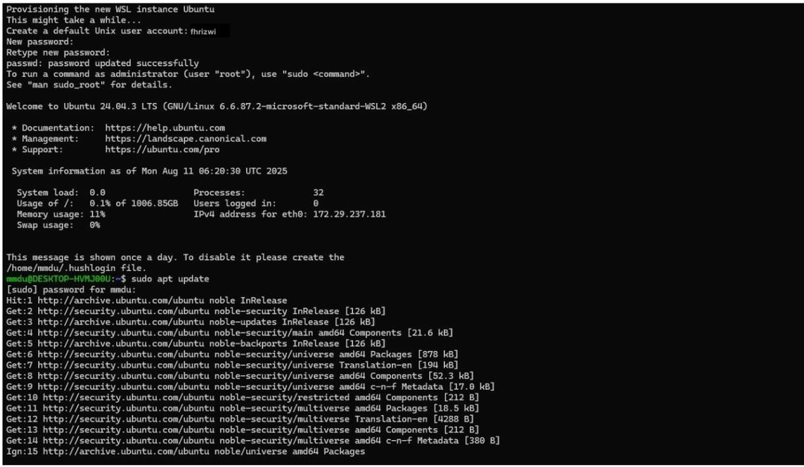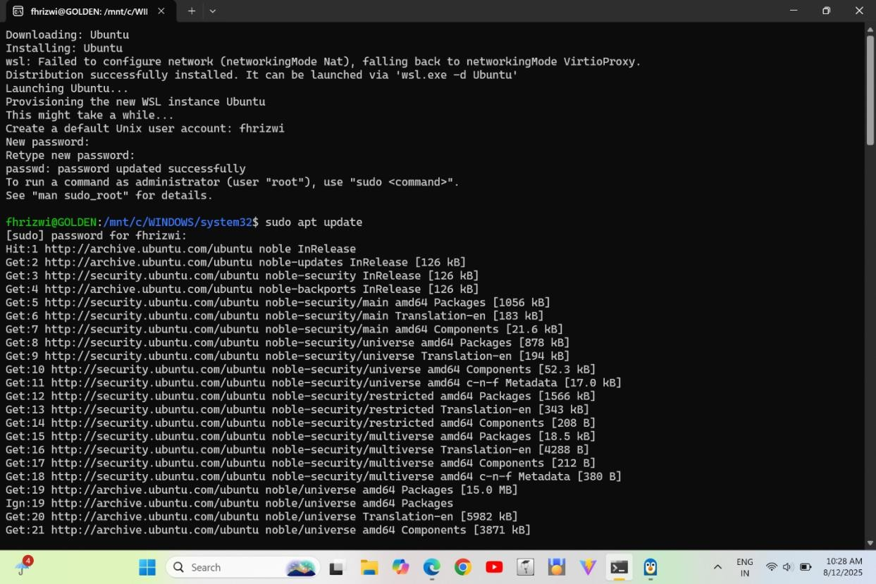
Hardik
_
Routel
a

